Exercise No: 4

Date: 14/10/2020

**Aim:**

To write a python program to print a single string from two set of strings received from user and swap the first two characters of each string.

**Program:**

def swap(d,e):

f=d[:2]+e[2:]

g=e[:2]+d[2:]

return g+' '+f

a=str(input()).strip()

b=str(input()).strip()

if(len(a)<2 or len(b)<2):

print("Invalid")

else:

c=swap(a,b)

print(c)

**Link:**

<http://103.53.53.18/mod/vpl/forms/submissionview.php?id=234&userid=1640>

**Output:**

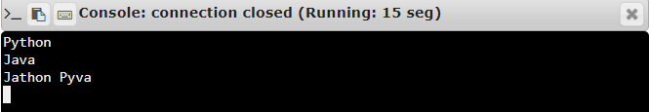

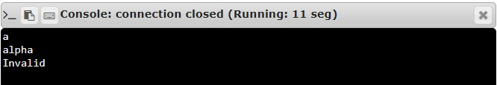

**Result:**

Thus, the program to swap first 2 character of 2 words is executed and required output is obtained.